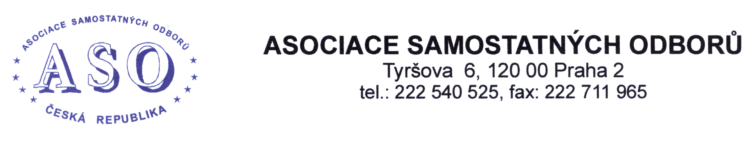
Invitation

to the

International Conference of the Association of Independent Trade Unions

A new strategy for collective bargaining at the time of the 4th Industrial Revolution, current social and economic trends and a future perspective

(The project of the Association of Independent Trade Unions “Social Dialogue as a Tool for Social Protection of Employees and Prevention of Discrimination on the Czech Labour Market” financed from the contribution to the activities under Section 320a letter a) of Act No. 262/2006 Coll., the Labour Code, as amended, to support social dialogue.)

Date: 28 December 2021 from 9: 30
Online transfer: from Hotel Olšanka, Táboritská 1000/23, 130 00 Praha 3-Žižkov

Due to the coronavirus pandemic situation, the international conference will be held by videoconference. The conference will be broadcast live via Czech News Agency (ČTK), the ASO portal www.odbory.info and the ASO Facebook page.

P R O G R A M

09.00 - 09.30 Registration of conference participants

09.30 - 09.45 Opening of the conference and welcoming of participants
Bohumír DUFEK, President of the ASO, member of the European Economic and Social Committee

09.45 - 10.00 Presentation by Jan WIESNER,
President of the Confederation of Employers' and Entrepreneurs' Associations of the Czech Republic

10.00 - 10.20 Updates from the European Parliament
Ivan DAVID, CSc., Member of the European Parliament

10.20 - 10.40 Minimum wage in the Czech Republic and the EU in relation to the standard of living of individual Member States and the posting of workers and theresults of the survey "The impact of advancing automation and digitalisation on the working competence of employees"
Ing. Jaroslav UNGERMAN, CSc., member of the European Economic and Social Committee

10.40 - 11.00 Agriculture and digitalisation and the new Common Agricultural Policy after 2021
Ing. Zdeněk JANDEJSEK, CSc., former President of the Agrarian Chamber of the Czech Republic, member of the Board of Directors of the Agrarian Chamber of the Czech Republic

11.00 - 11.20 Presentation of the expert study "The role of collective bargaining in the social protection of employees"
Ing. Josef ZBOŘIL

11.20 - 11.40 Break

11.40 - 12.00 Presentation of the survey results "The impact of collective bargaining on the position of employees on the labour market in the Czech Republic"
Ing. Markéta SLOVÁČKOVÁ, TREXIMA, spol. s.r.o.

12.00 - 12.20 Social impacts of the Czech energy transition
Ing. Marta CTIBOROVÁ, President of the Czech Trade Union of Energy Workers

12.20 - 12.40 The importance of collective agreements and workers' rights in the age of digitalisation of work, growing wage inequality, pay gaps across EU countries; working time and the future of pension systems and

Conclusion of the conference
Bohumír DUFEK, President of the ASO, member of the European Economic and Social Committee

The language of the conference will be Czech. The conference will be interpreted into the following languages:
English, German, Italian, Hungarian.

